3.2 The Derivative as a Function

Recall that in the last section we found functions that told us the slope of a tangent line at any point on a curve.

Definition: The derivative of a function f, denoted by is,

if this limit exists.

Note: Geometrically we know that is the slope of the tangent line to the graph of f at the point .

Example 1: If , then find the derivative of f. State the domain of f and the domain of its derivative.

Note: Some of you may know some derivative formulas/shortcuts. It is important to understand that if you are ever asked to find the derivative of a function USING ONLY the definition of derivative, you must complete the problem as we did in the above example.

Example 2: Find if .

Example 3:
Use the graph given below of the function to sketch a rough graph of .

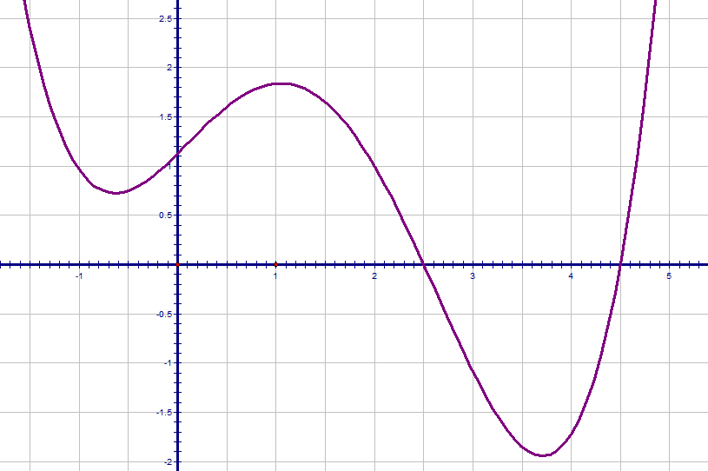

Example 4:
The graph of the function is shown below.
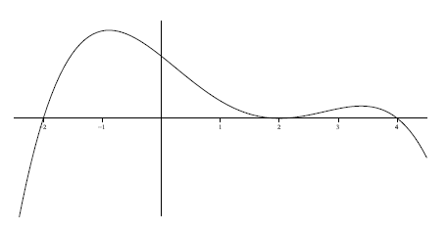

One of the six graphs below is the graph of . Circle the graph of .
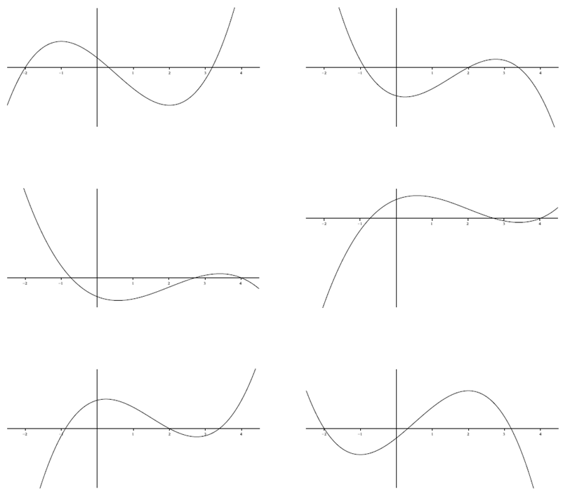

Notation: Somewhat unfortunately, there are many other notations for the derivative of .
In MTH 200 we will use the first five:

Note: The symbol is known as a differential operator, and this specific piece of notation is due to Leibniz.
Prime Notation:
The second derivative of f ,

The third derivative of f ,

Once we get above the third derivative we use numbers to indicated the number of primes.
In particular, the nth derivative of f is denoted when .

Leibniz Notation:
For Leibniz notation, the second derivative of is denoted: .
In general the nth derivative of is denoted: .

The advantage of using Leibniz Notation is that it shows important information about the derivative being calculated.

Note: We will study the meaning of higher order derivatives in later chapters.

Definition: A function f is differentiable at if exists.

It is differentiable on an open interval if it is differentiable at every number in the interval.

Example 5:
Show that is not differentiable at.

The next theorem gives us a relationship between differentiability and continuity.
Theorem: If is differentiable at a, then is continuous at a.

Proof:

Questions to the Class: 1. If a function is discontinuous at a, can it be differentiable at a?
2. If a function is continuous at a must it be differentiable at a?

Example 6: Consider. Note that the function is continuous at 0. Is it differentiable at 0?

How a Function can Fail to be Differentiable?
Remember that the derivative is the measure of the slope of the tangent line.
Therefore, if the tangent line has an undefined slope, is not in the domain of the derivative function, or if the graph is discontinuous or has a corner point then the derivative may be undefined.

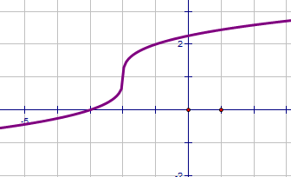
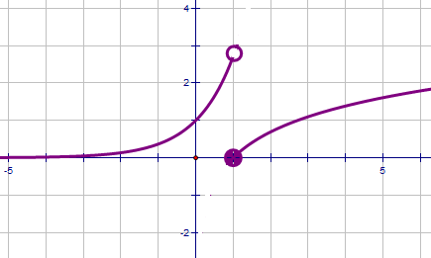
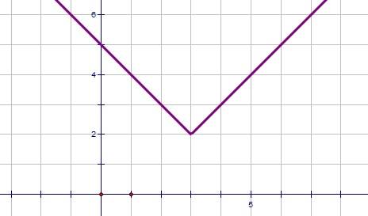

- A vertical tangent line (b) a discontinuity (c) a corner point

Example 7: Suppose that you are told exists.

- Based upon this information, where must f be continuous?

- What does equal?

